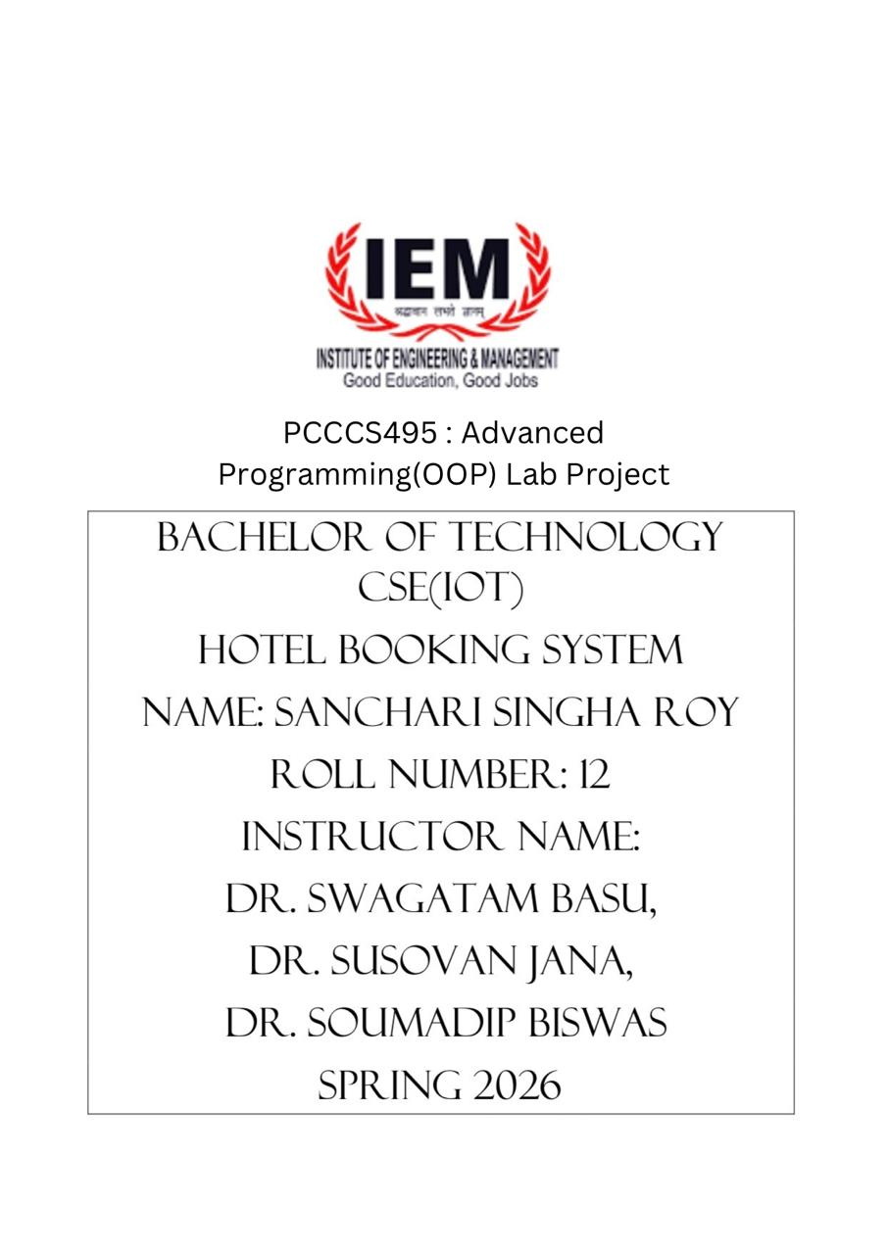

1. Problem Statement
In the hospitality industry, managing hotel room bookings efficiently is essential for smooth operations. Manual booking systems are prone to errors, inefficiencies, and difficulty in tracking room availability.
The objective of this project is to develop a console-based Hotel Booking System using Java that allows hotel staff to:
- View room details
- Check availability
- Book rooms
- Cancel reservations
The system should ensure:
- Accuracy in booking operations
- Prevention of double-booking
- Easy interaction via a menu-driven interface
- Proper handling of invalid inputs and errors

2. System Design

2.1 UML Class Diagram (Conceptual Description)
Main classes in the system:
- Room (Abstract Class)
- SingleRoom (Subclass)
- DoubleRoom (Subclass)
- Hotel
- Booking
- User Interface (Main Class)
Relationships:
- SingleRoom and DoubleRoom inherit from Room
- Hotel manages a collection of Room objects
- Booking links users with rooms
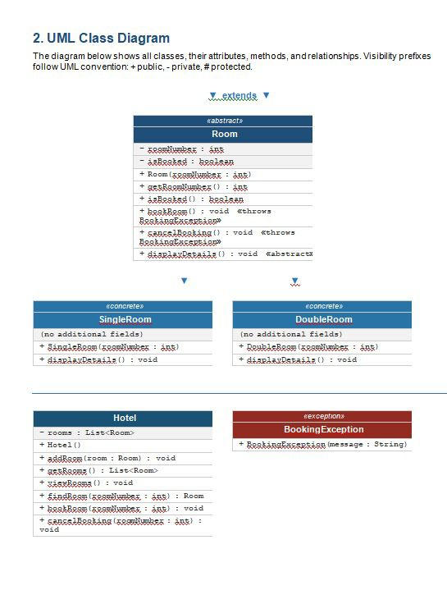

2.2 Description of Major Classes

1. Room (Abstract Class)
- Attributes: roomId, price, status
- Methods: displayDetails(), get/set methods
- Purpose: Acts as a base class for all room types

2. SingleRoom
- Inherits from Room
- Represents single occupancy rooms

3. DoubleRoom
- Inherits from Room
- Represents double occupancy rooms

4. Hotel
- Manages list of rooms
- Functions:
  - searchRoom()
  - bookRoom()
  - cancelBooking()

5. Booking
- Stores booking details
- Connects room and customer

2.3 Package Structure
hotel_booking/
│
├── model/
│ ├── Room.java
│ ├── SingleRoom.java
│ ├── DoubleRoom.java
│
├── service/
│ ├── Hotel.java
│ ├── Booking.java
│
├── main/
│ ├── Main.java

2.4 Interaction Flow
- User selects option from menu
- System displays available rooms
- User selects room
- Booking is processed
- Confirmation or error message displayed

3. OOP Concepts Demonstrated

3.1 Abstraction
Where used:
- Abstract class Room
Why used:
- To define a common structure for all room types
Code Snippet:
abstract class Room {
protected int roomId;
protected double price;
protected boolean isBooked;
abstract void displayDetails();
}
Explanation:
Abstraction hides implementation details and only exposes necessary functionalities.

3.2 Inheritance
Where used:
- SingleRoom and DoubleRoom extend Room
Why used:
- Code reuse and hierarchy creation
Code Snippet:
class SingleRoom extends Room {
void displayDetails() {
System.out.println("Single Room - Price: " + price);
}
}
Explanation:
Inheritance allows subclasses to reuse properties of the base class.

3.3 Polymorphism
Where used:
- Overriding displayDetails() method
Why used:
- Different behavior for different room types
Code Snippet:
Room room = new SingleRoom();
room.displayDetails();
Explanation:
Same method behaves differently depending on object type.

3.4 Encapsulation
Where used:
- Private variables with getters/setters
Why used:
- Protect data from unauthorized access
Code Snippet:
private boolean isBooked;
public boolean isBooked() {
return isBooked;
}
Explanation:
Encapsulation ensures controlled access to data.

4. Implementation Highlights

4.1 Room Booking Logic
public void bookRoom(int roomId) {
if (!room.isBooked()) {
room.setBooked(true);
System.out.println("Room booked successfully!");
} else {
System.out.println("Room already booked!");
}
}
Justification:
Prevents double booking and ensures consistency.

4.2 Room Search
public void searchRoom(int roomId) {
for (Room room : rooms) {
if (room.getRoomId() == roomId) {
room.displayDetails();
}
}
}
Justification:
Efficient way to locate specific rooms.

4.3 Cancellation Logic
public void cancelBooking(int roomId) {
if (room.isBooked()) {
room.setBooked(false);
System.out.println("Booking cancelled.");
}
}
Justification:
Allows flexibility and error correction.

4.4 Menu-driven Interface
System.out.println("1. View Rooms");
System.out.println("2. Book Room");
System.out.println("3. Cancel Booking");
Justification:
Improves usability for users.

5. Testing & Error Handling

5.1 Test Cases Considered
Test Case | Input | Expected Output
Valid booking | Available room | Booking successful
Double booking | Already booked room | Error message
Cancel booking | Booked room | Cancellation success
Invalid ID | Wrong input | Error

5.2 Edge Cases Handled
- Booking already occupied room
- Cancelling non-booked room
- Invalid room ID
- Empty room list

5.3 Failure Scenarios
- System prevents duplicate bookings
- Handles invalid inputs gracefully
- Displays meaningful error messages

6. Git Workflow
- Code maintained using GitHub
- Regular commits for:
  - Initial setup
  - Feature additions
  - Bug fixes
Includes:
- Commit history screenshot (to be added in final PDF)

7. Conclusion
The Hotel Booking System successfully demonstrates the application of Object-Oriented Programming principles in solving a real-world problem. The system ensures efficient room management through modular design, proper abstraction, and robust error handling.
It provides:
- User-friendly interaction
- Reliable booking operations
- Scalable design for future enhancements
Future improvements may include:
- GUI-based interface
- Database integration
- Online booking system

